# Overview

This document contains the necessary information to build Tactile Maps.

Contents

Overview 1

Maker Checklist 2

Maker To Do List 2

Items to Give to User 2

Tool List 2

Customization Guide 3

3D Printing Guide 4

3D Printing Summary 4

3D Printing Settings 4

Post-Processing 7

Examples of Quality Prints 7

Assembly Guide 12

Required Components 12

Required Tools 12

Required Personal Protective Equipment (PPE) 12

Step 1: Gather materials and tools 12

Step 2: Insert Braille labels into Tactile Maps Legend. 12

Step 3: Cut hook and loop tape 14

Step 4: Peel adhesive backing from hook side of tape 14

Step 5: Attach hook side of tape to map 15

Testing 15

# Maker Checklist

This list provides an overview of the steps required to build and deliver Tactile Maps.

## Maker To Do List

* Read through the Assembly Guide to become familiar with required components, tools, supplies, safety gear, and overall assembly steps.
* Talk to User about customization options (e.g., color, any special requests, etc.)
* Order hardware components
* Gather tools, supplies, and safety equipment.
* Assemble the device
* Test device
* Print “User Guide”

## Items to Give to User

* Assembled, tested device
* “User Guide”

## Tool List

* Scissors (optional)
* Hobby knife (optional)

# Customization Guide

The user may only want specific maps and/or features for the maps. Ask the user which maps and features they want, and how many of each they would like.

Ask the user if they want the map printed in a specific colour, and/or in two-tones. Users with partial sight may be able to see high contrast features on the map. If printing in two-tones, we recommend the following colour combinations:

* Black and white
* Black and bright yellow
* Dark blue and white
* Dark blue and bright yellow

You may also ask the user if they prefer a brighter colour on a darker background, or a darker colour on a lighter background.

The user may also want to be able to attach the maps to a surface using hook and loop tape. Ask the user if they would like hook and loop tape attached to the back of the maps and/or legend. If they do, place the hook side (scratchy side) of the hook and loop tape to the map and/or legend.

# 3D Printing Guide

## 3D Printing Summary

|  |  |
| --- | --- |
| **Metrics** | **Single Unit** |
| Total Print Time (min) | 2,122 |
| Total Number of Components | 23 |
| Typical Total Mass (g) | 289 |
| Typical Number of Print Setups | 16 |

## 3D Printing Settings

|  |  |  |  |  |  |  |  |
| --- | --- | --- | --- | --- | --- | --- | --- |
| **Print File Name** | **Qty** | **Total Print Time (hr:min)** | **Mass (g)** | **Infill (%)** | **Support(Y/N)** | **Layer Height/ Nozzle Diameter(mm)** | **Notes** |
| tactile  Maps  Legend.stl | 1 | 1:56 | 14 | 20 | N | 0.2/0.4 | - Print in orientation given in STL  - If printing in two-tones, add filament switch at layer 12 (2.4 mm) |
| fourWayStop.stl | 1 | 4:40 | 38 | 20 | N | 0.2/0.4 | - Print in orientation given in STL  - If printing in two-tones, add filament switch at layers 3 (0.6 mm) and 19 (3.8 mm) |
| large  Intersection.stl | 1 | 5:16 | 42 | 20 | N | 0.2/0.4 | - Print in orientation given in STL  - If printing in two-tones, add filament switch at layers 3 (0.6 mm) and 19 (3.8 mm) |
| offset  Intersection.stl | 1 | 4:39 | 39 | 20 | N | 0.2/0.4 | - Print in orientation given in STL  - If printing in two-tones, add filament switch at layers 3 (0.6 mm) and 19 (3.8 mm) |
| pedestrian  Crossing  Map.stl | 1 | 6:02 | 53 | 20 | N | 0.2/0.4 | - Print in orientation given in STL  - If printing in two-tones, add filament switch at layers 3 (0.6 mm) and 19 (3.8 mm) |
| roundabout  Map.stl | 1 | 5:17 | 43 | 20 | N | 0.2/0.4 | - Print in orientation given in STL  - If printing in two-tones, add filament switch at layers 3 (0.6 mm) and 19 (3.8 mm) |
| TIntersection.stl | 1 | 5:24 | 47 | 20 | N | 0.2/0.4 | - Print in orientation given in STL  - If printing in two-tones, add filament switch at layers 3 (0.6 mm) and 19 (3.8 mm) |
| bike  LanePiece.stl | 1 | 0:03 | 0.125 | 20 | N | 0.2/0.4 | - Print in orientation given in STL |
| bike  LaneLabel.stl | 1 | 0:13 | 1 | 20 | N | 0.2/0.4 | - Print in orientation given in STL |
| bus  StopPiece.stl | 1 | 0:02 | 0.125 | 20 | N | 0.2/0.4 | - Print in orientation given in STL |
| bus  StopLabel.stl | 1 | 0:12 | 1 | 20 | N | 0.2/0.4 | - Print in orientation given in STL |
| mail  BoxPiece.stl | 1 | 0:02 | 0.125 | 20 | N | 0.2/0.4 | - Print in orientation given in STL |
| mail  BoxLabel.stl | 1 | 0:11 | 1 | 20 | N | 0.2/0.4 | - Print in orientation given in STL |
| pedestrian  CrossingPiece.stl | 1 | 0:02 | 0.125 | 20 | N | 0.2/0.4 | - Print in orientation given in STL |
| pedestrian  CrossingLabel.stl | 1 | 0:26 | 3 | 20 | N | 0.2/0.4 | - Print in orientation given in STL |
| rail  CrossingPiece.stl | 1 | 0:02 | 0.125 | 20 | N | 0.2/0.4 | - Print in orientation given in STL |
| rail  CrossingLabel.stl | 1 | 0:18 | 2 | 20 | N | 0.2/0.4 | - Print in orientation given in STL |
| stop  LightPiece.stl | 1 | 0:01 | 0.125 | 20 | N | 0.2/0.4 | - Print in orientation given in STL |
| stop  LightLabel.stl | 1 | 0:14 | 2 | 20 | N | 0.2/0.4 | - Print in orientation given in STL |
| stop  SignPiece.stl | 1 | 0:01 | 0.125 | 20 | N | 0.2/0.4 | - Print in orientation given in STL |
| stop  SignLabel.stl | 1 | 0:10 | 1 | 20 | N | 0.2/0.4 | - Print in orientation given in STL |
| yield  SignPiece.stl | 1 | 0:01 | 0.125 | 20 | N | 0.2/0.4 | - Print in orientation given in STL |
| yield  SignLabel.stl | 1 | 0:10 | 1 | 20 | N | 0.2/0.4 | - Print in orientation given in STL |

## Post-Processing

Clean up any stringing or rough edges that may have occurred.

## Examples of Quality Prints

**Photo of Legend and Labels**

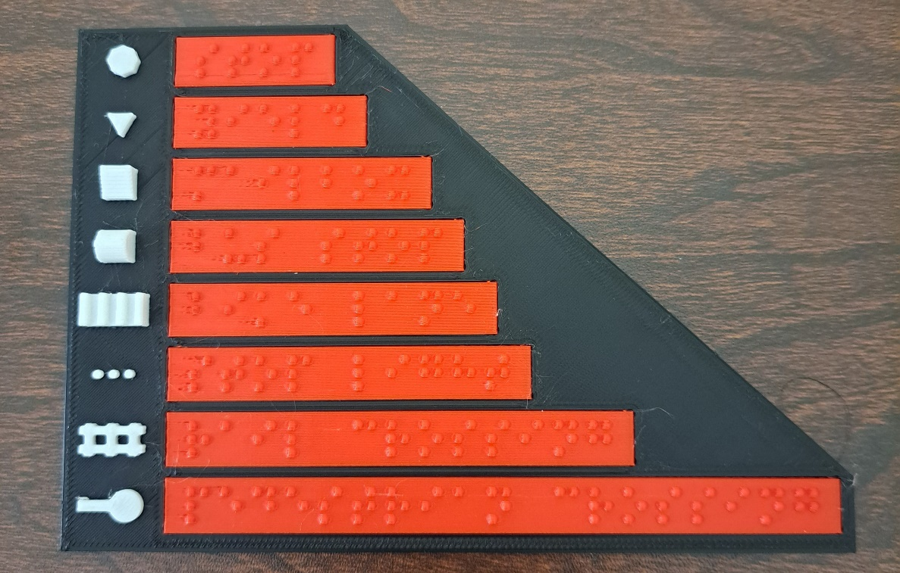

Figure 1: Legend and Braille labels. The labels have been printed separately in red to give contrast with the background. The legend was printed in one piece with a filament change to contrast the features and the background.

From top to bottom the symbols represent a stop sign, a yield sign, a mailbox, a bus stop, a bike lane, a stop light, rail tracks, and a pedestrian crossing. The labels read: “stop”, “yield”, “mailbox”, “bus stop”, “bike lane”, “stop light”, “rail crossing”, and “pedestrian crossing”.

**Photo of Four Way Stop Map**

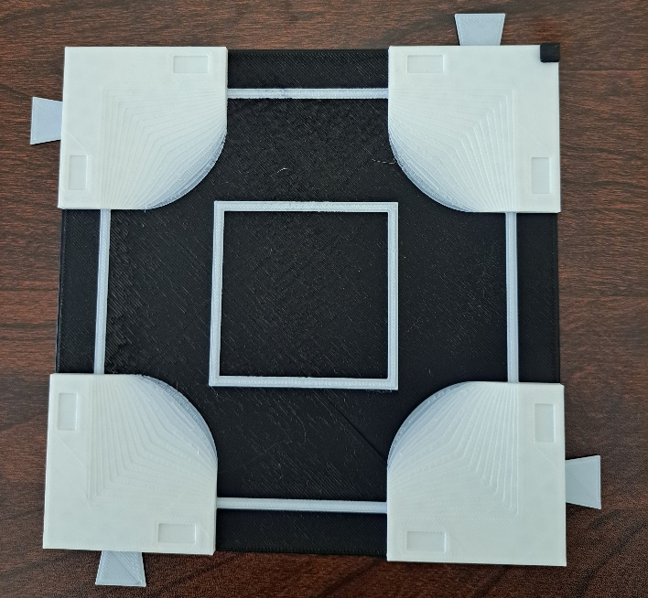

**Photo of Large Intersection Map**

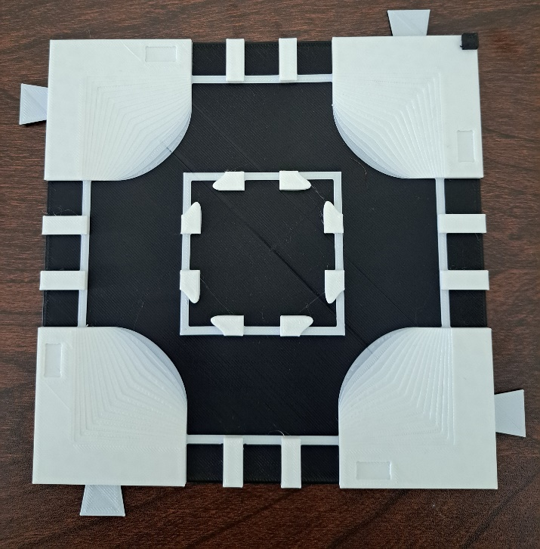

**Photo of Offset Intersection Map**

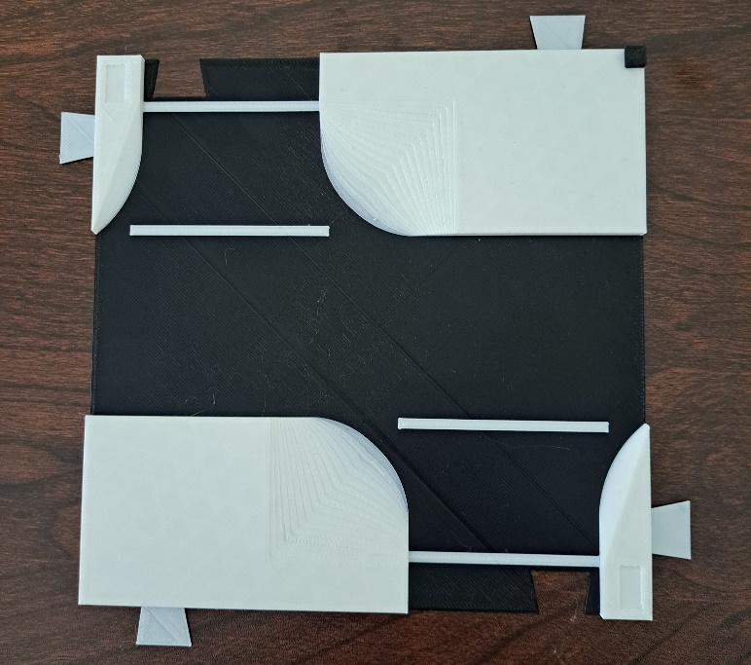

**Photo of Pedestrian Crossing Map**

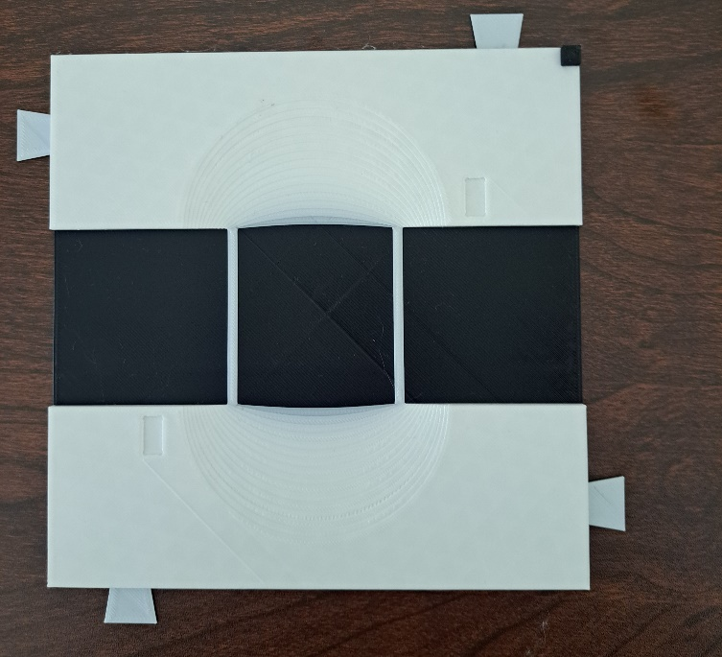

**Photo of Roundabout Map**

**Photo of T Intersection Map**

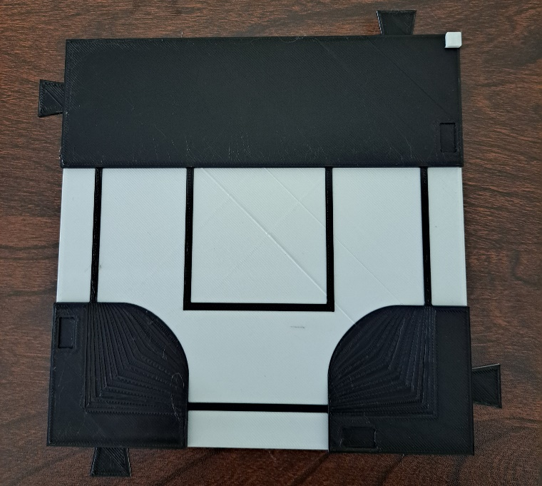

**Photo of Features**

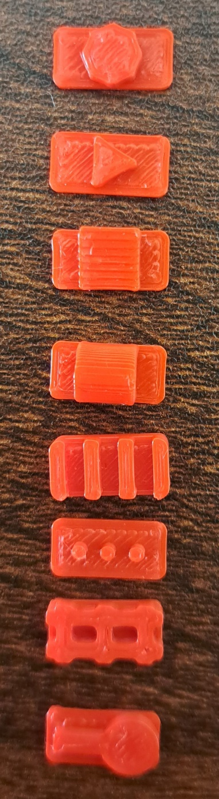

3D printed features that represent from left to right: Stop signs, yield signs, mailboxes, bus stops, bike lanes, stop lights, railroad tracks, and pedestrian crossings.

# Assembly Guide

## Required Components

|  |  |
| --- | --- |
|   **4.**  **3.**  **1.**  **2.** | **BOM**   1. Tactile Maps Legend 2. Braille Legend Labels 3. Super glue (optional) 4. Hook and loop tape (optional) 5. Scissors (if using hook and loop tape, not pictured) 6. Tactile map(s) (not pictured) |

## Required Tools

* Super glue (optional)
* Scissors (if using hook and loop tape)

## Required Personal Protective Equipment (PPE)

* Safety glasses

### Step 1: Gather materials and tools

Gather all materials and tools listed in the Required Components. Ensure you also have any tactile maps the user requested. They are not pictured in the Required Components as there are six general maps a user may request.

### Step 2: Insert Braille labels into Tactile Maps Legend.

Insert the Braille labels into the corresponding spaces on the legend. The labels will fit into their corresponding space snuggly. Ensure the labels are the correct orientation, and that the raised Braille characters are exposed. If you cannot read Braille, refer to the Photo of Legend and Labels under Examples of Quality Prints, or the labels in the Required Components as they are in the correct orientation.

If a label is loose in its space, you may apply some super glue to secure the label in the legend.

|  |
| --- |
| A hand placing a Braille label into the Tactile Maps Legend.  A hand holding a bottle of glue and applying the glue to the back of the Braille label. |

Place all labels into the legend. If the user did not request hook and loop tape, assembly is now complete. If they did request hook and loop tape, repeat the following steps for all maps the user requested.

### Step 3: Cut hook and loop tape

Cut two, 8 cm long sections of hook and loop tape for each map.

|  |
| --- |
|  |

### Step 4: Peel adhesive backing from hook side of tape

Peel the adhesive backing off the hook (scratchy) side of the hook and loop tape.

|  |
| --- |
| The backing of the hook (scratchy) side of the hook and loop tape being peeled off. |

### Step 5: Attach hook side of tape to map

Attach the hook side of the hook and loop tape to the back of the tactile map. Attach two pieces per map. Ensure you do not cover the cut-outs where the tabs secure multiple maps together (circled in red in the picture).

|  |
| --- |
| Hook side of hook and loop tape attached to the back of a tactile map. The cut-outs where tabs connect adjacent maps are circled in red. |

Repeat Steps 4 and 5 for all maps the user requested, and the legend if they requested hook and loop tape on it as well.

# Testing

Place the traffic sign/signal pieces into the cut-outs on the tops of the maps. They should fit snuggly and not fall out when you run your hand over them, but still be easy to pop out of the cut-outs.

|  |
| --- |
| A tactile map of a large intersection with pieces placed on the map to represent stop signs, stop lights, and yield signs. The base of the map is black, the sidewalks and crosswalk lines are white, and the features are red. |

If the user requested multiple maps, ensure the maps can fit together, as shown below. The tabs and cut-outs should fit together securely and keep the maps from separating when you run your hand across them.

|  |
| --- |
| Two tactile maps connected together by the tabs on the edges of the maps. The two maps represent an offset intersection and pedestrian crossing. |